**Establishing Criteria for the Improvement of Pedestrian Facilities Based on Crossing Index**

**CHAPTER 1**

**1.1 Introduction**

Walking is a regular activity for everybody. Individuals walk regularly to some distance for various purposes in dissimilar grounds. Pedestrians of all types, including both sexes with numerous aging groups are always subjected to risk. Besides, the pedestrians are categorized as the most exposed of road users. Youngsters and aged peoples are regarded as being at an increased-threat regarding pedestrian crashes or mishaps (Satiennam et al. 2005). Malaysia is one of the countries that experiencing rapid growth in motorization, automobile and transportation systems. This rapid growth in economics is due to the escalation of population, for which, the necessity of this project becomes inevitable. In recent years, substantive numbers of accidents have been recorded pertaining to the pedestrians as well as the road systems. Literately, the road safety is a real concern in Malaysia; nowadays. Current research data shows deficiencies that require perpetual means of solution for. With this timely-theme in mind, this project will find a way to improve the present system, relevant to the pedestrian crossing-index.

**1.2 Problem statement**

The proposed topic is an important research because it may bring clarity in the process of establishing crossing-index for the pedestrians while justify the observation of timely needs in Kuala Lumpur, Malaysia. The current model has a margin where improvement seems to be as an essential; as it has severe deficiencies due to continuous development for decades. Today we have too many confusion over the proper crossing-index and therefore re-evaluation becomes a necessary. Improper recommendations lead to accidental rate-hike and pave ways for re-assessment on the current crossing-index. Besides, this particular problem creates dissatisfaction among pedestrians, cyclists and transporters towards the government policies, which turns to be ideological imbalances. Hence a precautionary step need to be taken to identify the sufficient crossing-index, otherwise situation may get worst for the upcoming years. Enormous reflection will be resulted during the measurement of success of nation, if this problem is not solved today.

**1.3 Objective**

The main objective of this research is to optimize the current model of the sustainability index of the gap-crossing-behaviors of both, the pedestrians and cyclists. In order to achieve the main objective, several key points are sorted out. They are:

1. As to determine the severity level of the existing pedestrian gap crossing behaviors at selected metropolitan areas in Kuala Lumpur, Malaysia.
2. Recalculate or re-compute or remodel the current predicting mechanism as to cope the rapid changes.
3. As to improve the sustainable pedestrian gap crossing-index based on traffic flow density along the selected road junctions.

**1.4 Research Scope**

The scope of this research study is to re-estimate the current crossing-index while encouraging for any other possible future improvements. However, there will not be any new methodology applied in whatsoever means but rather following the conventional approaches to minimize the present index. The current situation utilizes surveys and observations and of course, this research lays similar foundation; as before had. Hence, the limitation fall within the metropolitan areas and therefore only the city streets are concern of.

**1.5 Thesis organization**

The thesis is organized in five chapters. A brief description of the content of each chapter is given below.

Chapter 1: narrates the introduction, problem statement, objective, research scope and the thesis organization.

Chapter 2: provides detailed information about the background study pertaining to literature review. Some preliminary data has been included in, by.

Chapter 3: explains the research methodology that used to model the crossing-index in addition to relevant information.

Chapter 4 discusses new results that obtained through the improved-model for crossing-index of the pedestrians and cyclists.

Chapter 5: concludes the research with newly computed result for 2016, metropolitan areas in Malaysia.

Chapter 6: References

Chapter 7: Appendixes

**CHAPTER 2**

**2.1 lITERATURE REVIEW**

Developing countries are getting busier and busier, perhaps it happens day by day. As the nation rises economically, the metropolitan cities are designed to commutate and support more people to boost economical strength. Hence the infrastructures are getting closer to one another, having compact living packs; nowadays. Expecting facilities such as schools, hospitals, work places, leisure malls and etc become common for modern era people. So moving around of all these areas becomes noticeable factor in recent years as the pedestrian accidents escalate over the time. With this issue in mind, some preliminary studies have been considered to understand the current trends as well as additional technique to improve policies for the pedestrians around Kuala Lumpur, Malaysia. Pedestrian gap acceptance is one of the most important components in microscopic traffic characteristic in pedestrian road crossing-index. Raghuram Kadali et al. (2012) has observed several road junctions in the Metropolitan areas in India and suggested that the discrete choice theory can be applied to create a mathematical model as to contribute to the reduction of the pedestrians’ accidents. On the similar side of the problem, Marisamynathan et al. (2013) has discussed his concerns over the problems that faced by pedestrians at signalized intersection crosswalks, in which, the pedestrian delay become important parameters to consider. Let’s look at the figure 2.1 for a well known model that compares the walking speed at vertical sides against the gender, aging group, location and the traffic signal on the horizontal sides. He has noticed that the pedestrians adjust their crossing speed based on the traffic condition at that specific time.

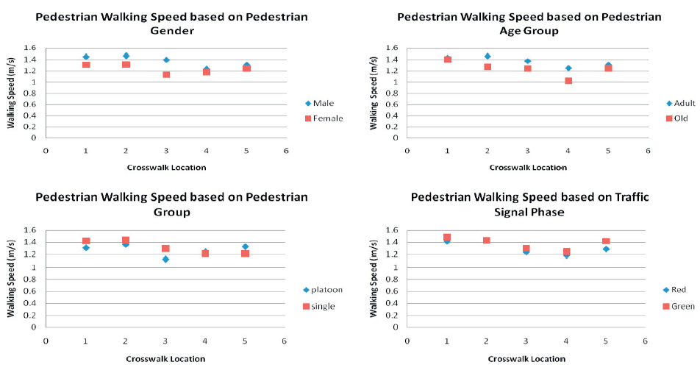

Figure 2.1: Pedestrian walking speed based on pedestrian and traffic characteristics at selected intersection crosswalk in Mumbai.

Boon HG et al. (2012) has measured such parameters (crossing-speed) and concluded that the childrens’ category crosses at a speed of 1.31 m/s while the adults’ category crosses at a speed of 1.53 m/s and the old peoples’ category crosses at a speed of 1.09 m/s in Malaysia. Boon HG et.al (2012) has also added that the current design on traffic signal using 1.22 m/s does not provide sufficient time for pedestrian to cross safely; see at table 2.1.

Table 2.1: Pedestrian crossing speed at signalized crosswalk

|  |  |  |  |  |
| --- | --- | --- | --- | --- |
| Conditions | Categories | Crossing speed (m/s) | | |
| Mean | 85% | 15% |
| Day time | Male Children | 1.46 | 1.65 | 1.27 |
| Female Children | 1.35 | 1.56 | 1.07 |
| Male Adult | 1.41 | 1.65 | 1.20 |
| Female Adult | 1.31 | 1.47 | 1.17 |
| Male Elderly | 1.23 | 1.40 | 1.04 |
| Female Elderly | 1.18 | 1.38 | 1.02 |
| Night time | Male Children | 1.43 | 1.70 | 1.20 |
| Female Children | 1.27 | 1.51 | 1.07 |
| Male Adult | 1.39 | 1.61 | 1.18 |
| Female Adult | 1.32 | 1.51 | 1.13 |
| Male Elderly | 1.23 | 1.46 | 1.01 |
| Female Elderly | 1.15 | 1.88 | 0.82 |
| Overall |  | 1.31 | 1.53 | 1.09 |

Rizati Hamidun et al. (2013) has slightly different perception in the matter as they believed that pedestrian are most at risk when crossing a road section with a large amount of pedestrian-vehicle interactions. So, the multiple alternative-access points are recommended for metropolitan areas in Kuala Lumpur as to reduce the pedestrian-vehicle interactions.

Akash Jain et al. (2014) have different angle in the subject matter as they argue that: “among the crossing patterns more pedestrians crosses the roads in perpendicular direction and very few of them crosses the roads in two stages (table 2.2). This is an absolute negligence of pedestrians, which has been categorized into the crossing behavior category of pedestrians.

Table 2.2: Pedestrians crossing patterns

|  |  |  |
| --- | --- | --- |
|  | Percentage of Pedestrian (%) | |
| One Step Crossing | Two Step crossing |
| Perpendicular Crossing | 53.98 | 7.36 |
| Oblique Crossing | 31.90 | 6.74 |
| Overall | 85.89 | 14.11 |

Rizati Hamidun et al. (2015) have checked the Akash Jains’s idealogy at the Masjid Jamek, Kuala Lumpur area, an intersection between LRT station and main road traffic light pedestrian ways. Results show that Malaysian is having almost similar attitudes that of the Akash Jains’s theory predicts (figure 2.2).



Figure 2.2: a scenario at the LRT station and main road traffic light pedestrian way (Kuala Lumpur, Malaysia)

A field survey was carried out at nine uncontrolled mid-block locations in different streets in three Egyptian cities by Serag MS (2015) and the result has shown that Egyptian pedestrians rely mainly on rolling gap and accept small traffic gap size without much waiting at the curb, which proves that the behavior of pedestrians in Egypt is particularly non-compliant and often risk-taking types. Though this type of attitude is deemed to be an usual behavior in many developing countries, as it is, in fact, a matter of serious mistakes against compliances (figure 2.3).



Figure 2.3: Careless pedestrians in Egyptian roadsides

George Yanis et al. (2010) have also inspected the gap acceptance in Greece and concluded that pedestrians crossing decisions are strongly associated with the distance from the incoming vehicle, rather than its speed, possibly because vehicle distance can be more easily assessed by pedestrians. Literally, the pedestrians crossing decisions are utterly subjected to the pedestrians’ self-predicting-capabilities regardless of aging or genders’ parameters. Abdul Aziz et al. (2000) have released an experimental result, that 70% of automotive users often disobey traffic signals at road junctions in Malaysia. As a precautionary step, the government of Malaysia has recently implemented the monitoring system (AES) around metropolitan areas by vehicles in 2010, from which the purposely-disobeying road users are severely in accordance with legal means (figure 2.4).

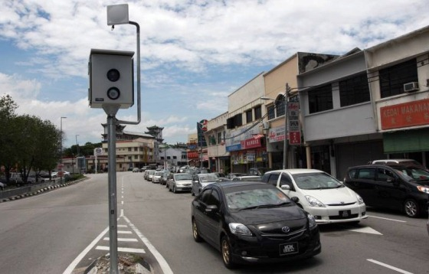

Figure 2.4: AES in Kuala Lumpur

Bahari NI et al. (2012) have found that the elderly peoples prefer to adhere pedestrian rules whereas the youngsters or children consider those rules very rarely. This is an obvious problem at which more focus is required, as stated by Bahari in his pedestrian’s research articles. “It was observed that the probability of accepting a spatial gap decreases with the increase in the approaching vehicle speed. It was also found that pedestrians accept smaller gaps if the conflicting vehicle is smaller, such as two-wheeler or auto-rickshaw” – Digvijay et al. (2015) has reported in a prominent journal when conducted a survey in India. However, Digvijay et al. (2015) results are unacceptable in Thailand, Vietnam, Indonesia and Malaysia; as the WHO record discloses severe discrepancies in death toll (table 2.3).

Table 2.3: Deaths by VRU category

|  |  |  |
| --- | --- | --- |
| Country | Fatalities at road | Pedestrians |
| Malaysia | 6,282 | 10.1% |
| France | 4,620 | 12.1% |
| Hungary | 1,232 | 22.7 % |
| Italy | 5,669 | 13.4% |
| Portugal | 1,110 | 16.1% |
| Spain | 4,104 | 15.0% |
| Japan | 6,639 | 32.3% |

Aqbal et al. (2012) has also revealed that fatal happened due to severe injuries in head and is about 35% in Malaysian cases. Rizati Hamidun (2015) from the Malaysian Institute of Transport, an official for transport system in Malaysia has categorized the main parameters as: 1) human, 2) environment and 3) engineering, as to improve the current mechanism for betterment. Rizati Hamidun (2015) has emphasized coherence improvements in these three categories will ensure a developed nation status. Bishnu Prasaad (2011) has dissimilar policies to avoid accidents as he suggests regulating the speed of pedestrians while crossing road at any junctions. His analysis shows that the pedestrians speed proportionally varies upon their educational levels (figure 2.5).

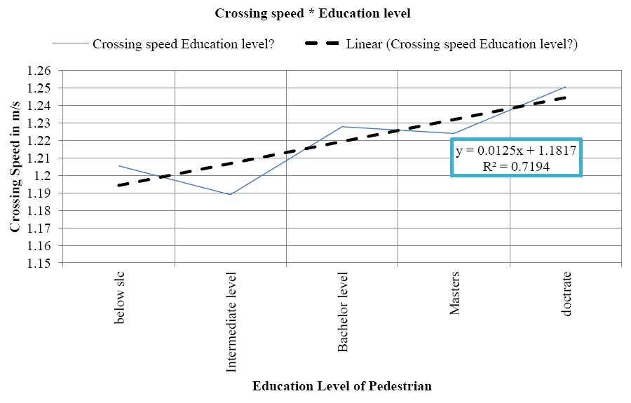

Figure 2.5: Pedestrians speed versus educational levels

This should be taken in positive way as to reduce the accidental rate. In mixed traffic conditions, Raguram Kadali et al. (2013) have found that the error of prediction deviates significantly, paving ways for uncertainties which may lead to accidents. Thus, the pedestrian's gap predicting behavior is a complex one and it is supposed to be influenced by pedestrian's physical characteristics, pedestrian tactics, available gap size and speed of the vehicle. Let’s look at figure 2.6 as it illustrates a wrong computation that made by a pedestrian.

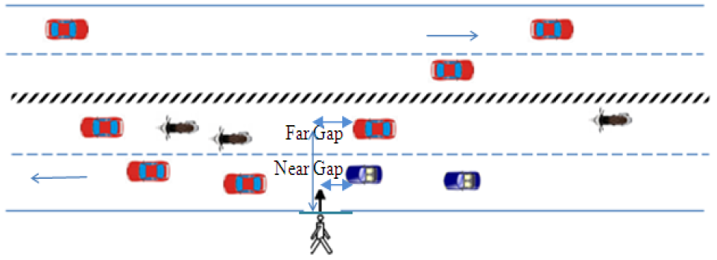

Figure 2.6: Critical mid-block unsignalized pedestrian road crossing section.

Norrizam Daud et al. (2008) has carried out extensive mathematical modeling, pertaining to negative binomial distribution, which reveals a better fit for the night-time and daytime of pedestrian accident data as compared to the poisson’s distribution. This type of mathematical models becomes breakthrough as it leads to imagine beyond borders to rectify uncertainties. Although researchers have done extensive and substantial research works on the field up to now, still solid conclusion is an ambiguity. So, some information was referred back from the US dept of transportation, a well structured and organized guidance, having the usage of Ped ISI (Pedestrian Intersection Safety Indices). From the guidance, the following sentence was somehow shocking news but a lesson for developing countries. Adapted from the booklet of US dept of transportation: “National crash statistics for 2004 show that 4,641 pedestrians were killed in crashes, accounting for approximately 13 percent of all traffic fatalities in the United States”.

The current Ped ISI value is 2.7 in USA. Malaysia is still far away from super-computation and therefore, a rigorous study and analysis is required in Kuala Lumpur for the upcoming years. Bahari NI et al. (2012) have calculated that the entire Kuala Lumpur is connected with 43.121 km of pedestrian way, which is shown in figure 2.7.



Figure 2.7: Pedestrian’s walkway (43.121 km) around Kuala Lumpur city

While researchers have various concerns over the subject matter, Suhaila AH et. al. (2015) went to one step higher and analyzed the factors that contributed by hand phone usage during the road-cross-behaviour. Suhaila AH et al. have determined through survey that mobile phone affects the line of sight of pedestrians while crossing the roads or junctions. Look at figure 28, that shows a pedestrians behavior that affect the line of sight due to cell phone conversation.

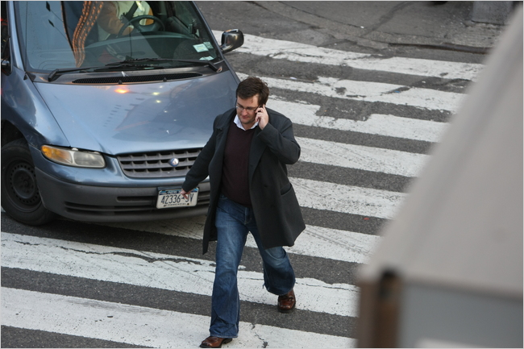

Figure 2.8: Pedestrian’s attitude with mobile phone

After knowing all the complexity factors in this field and with the breakthrough of this magnitude: an improvement for the crossing index is yet inevitable. So the research work on this project will be focusing on the improvement of such things, henceforth.

**CHAPTER 3**

**3.1 METHODOLOGY**

Giving priority to a traffic junction at the heart of Kuala Lumpur, a street that named Jalan Ampang (KM 1.60 to KM 2.60) at which the streets of houses, international embassies, international schools and local hospitals are located. This street seems to be metropolitan area and old enough since early 1970sand of course, with sufficient number of pedestrian gap crossing along street sides. As such, it is selected to be the hot spot of the analysis, as to know the severity of the current condition through the sustainability index of the gap-crossing-behaviors of the pedestrians.